All 5 retail microservices applications deployed using Helm and ArgoCD. Heathy and Synced.
Plan:
1. Inspect the existing Argo CD installation and current applications.
2. Create an Argo CD Application for each Helm chart: ui, catalog, carts, checkout, and orders.
3. Point each application to its chart under helm/<service>.
4. Enable automated sync, pruning, and self-healing.
5. Safely adopt the existing Helm-managed resources without recreating the application.
6. Test GitOps by changing Git and watching Argo CD reconcile EKS.
7. Then move into Argo Rollouts and observability. 🚀
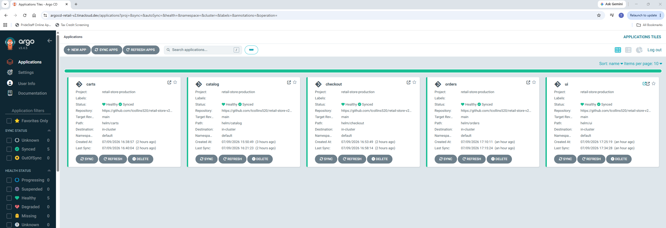
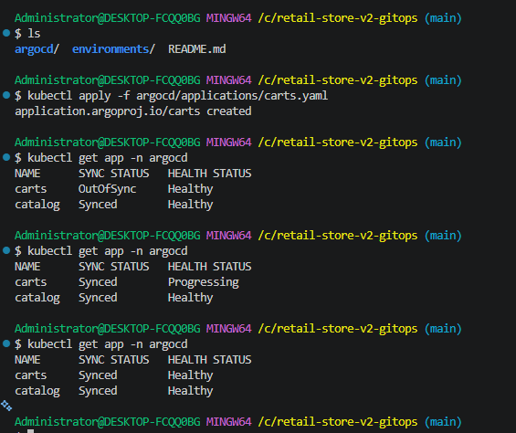
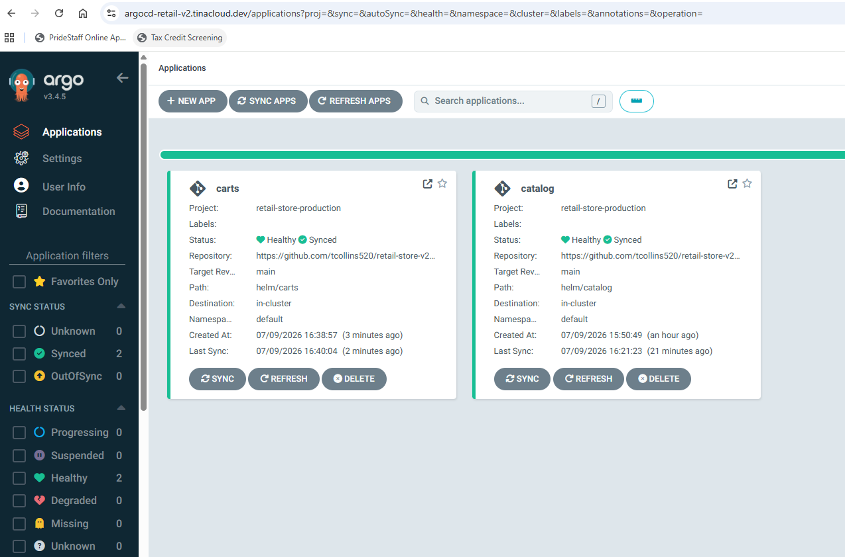
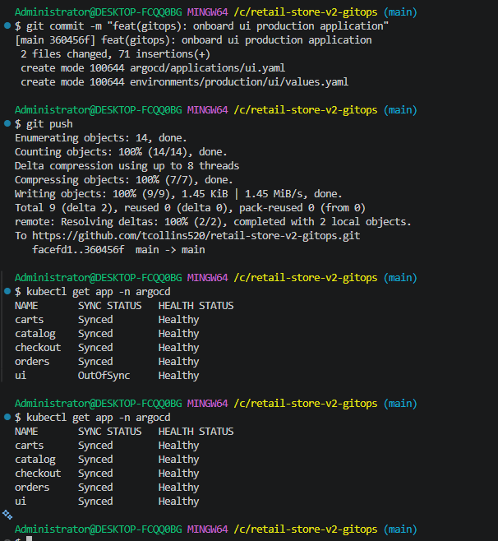
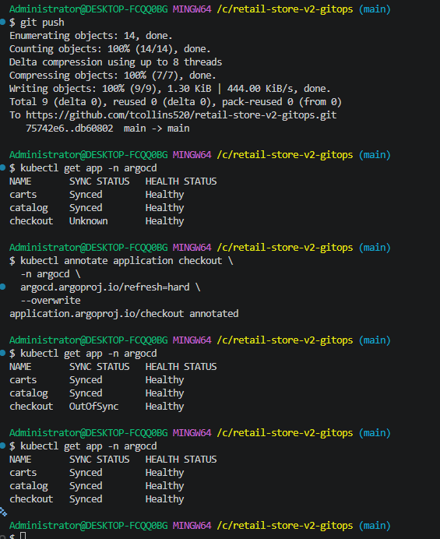
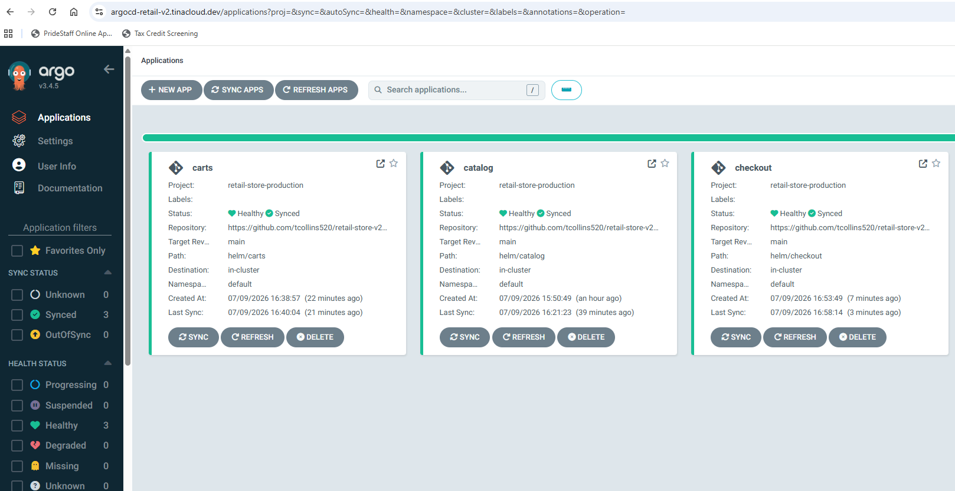
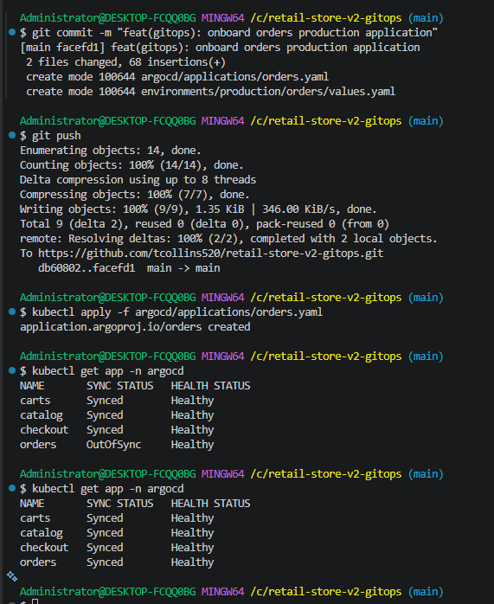
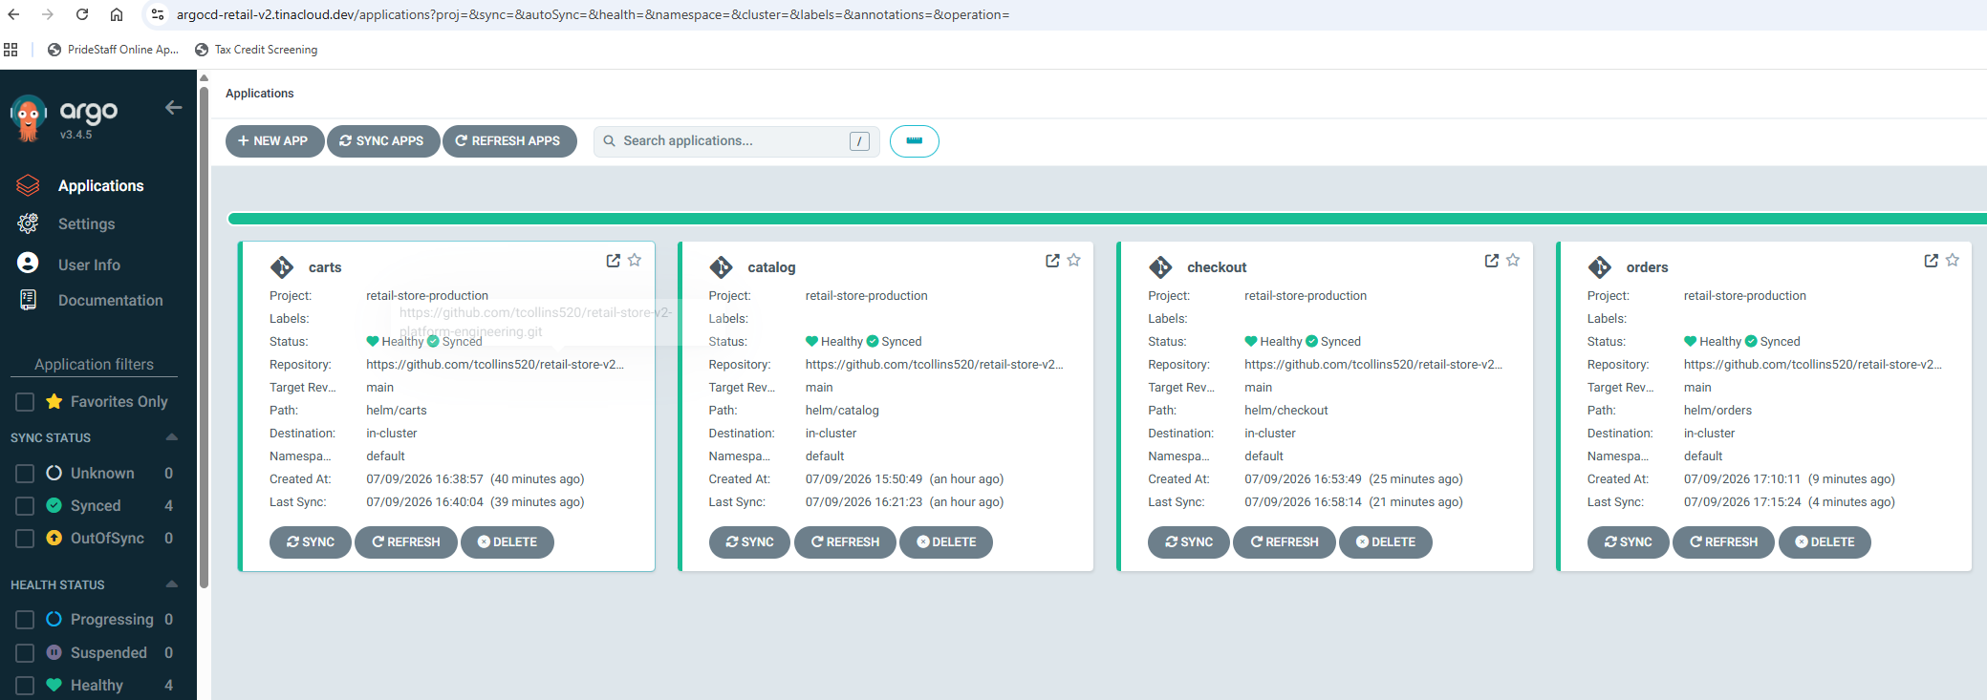

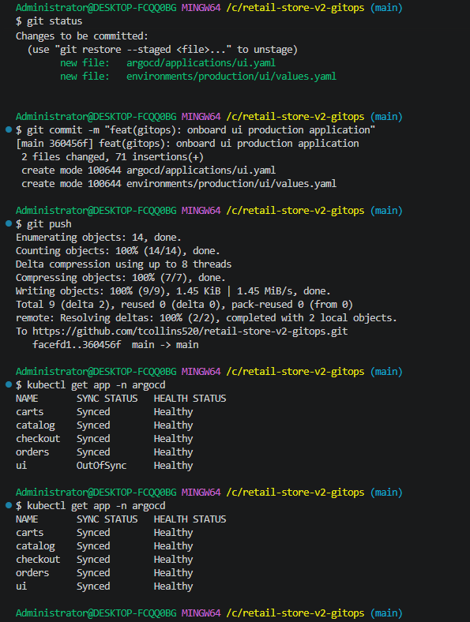

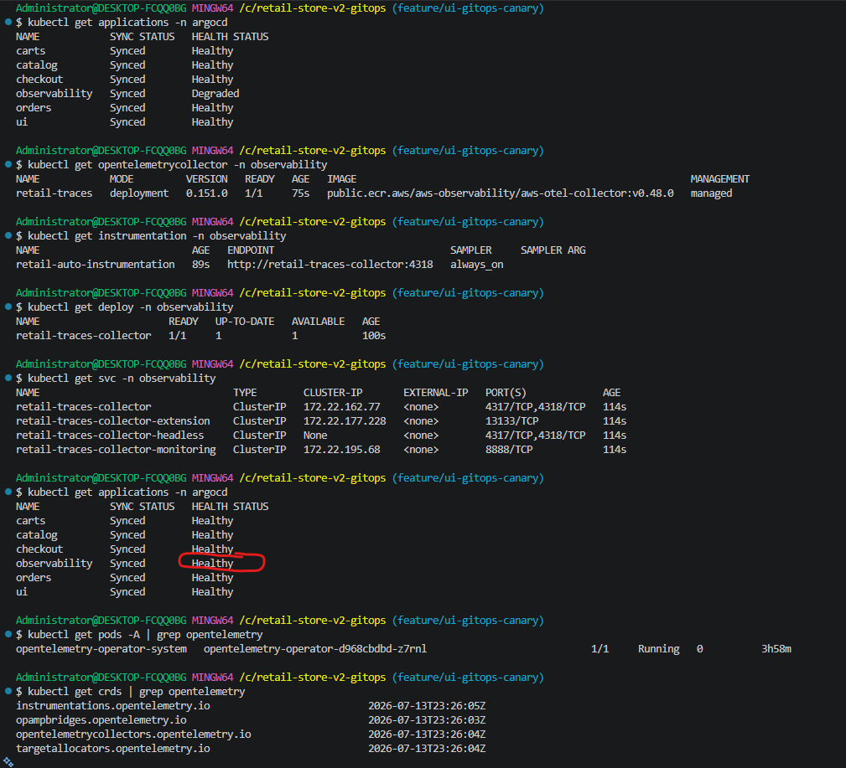
GitHub
│
GitHub Actions
│
▼
Argo CD GitOps
│
┌─────────────────┼──────────────────┐
│ │ │
Helm Apps Kustomize OTel Rollouts
│ │ │
▼ ▼ ▼
Catalog OpenTelemetry Canary Releases
Orders Collector
Checkout Instrumentation
UI
Carts

